ALL INDIA ANGLING FEDERATION
(governing body of Angling Game in India)
Govt.of India Notary Certified
An Internatonally approved Member

About Us
Aim & Object
Affiliation
Championships
Participation
Contact
Debroy Mansion
Dhaleswar Road no.8
Agartala -799007
Tripura State,
India

Email : angling.india@gmail.com
Mob.+91-7085769877

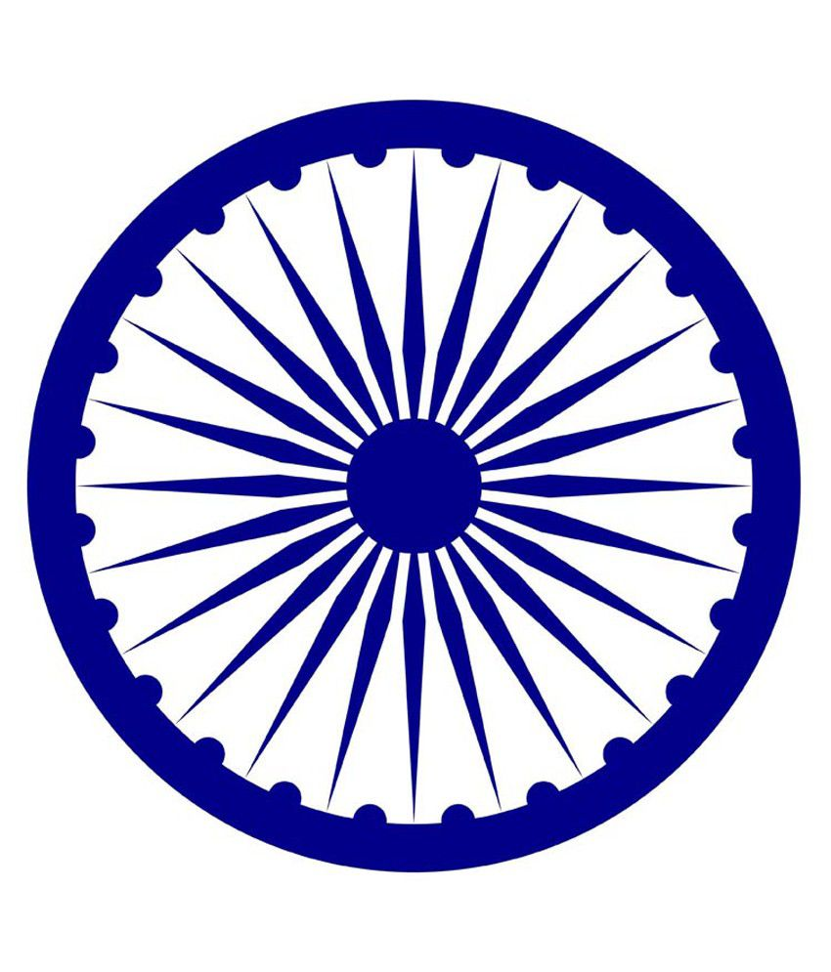LOGO in left Side

